Day 18
--------------- BASIC LINUX COMMANDS ------------------------------------
- ls > files.txt redirects the output of the ls command to files.txt, replacing any existing content in the file.
- cat files.txt displays the contents of files.txt on the terminal screen.
- echo "New entry" >> files.txt appends the text "New entry" to the end of files.txt without overwriting the existing content.
- echo -e "banana\napple\ncherry" > fruits.txt creates a file named fruits.txt and stores the words banana, apple, and cherry on separate lines.
- The -e option tells echo to interpret escape characters such as \n as new lines.
- ls /not_a_real_folder 2> errors.txt redirects any error messages generated by the command into errors.txt instead of displaying them on the terminal.
- ls | wc -l passes the output of ls to wc -l, which counts the number of lines and displays the total number of files and directories.
- ps a displays processes associated with the current terminal session.
- ps au displays detailed information about processes running for terminal users.
- ps aux displays detailed information about all processes currently running on the system.
- ps aux | grep bash filters the process list and shows only the entries that contain the word bash.
- du -sh * displays the disk usage size of each file and directory in a human-readable format.
- du -sh * | sort -rh sorts the disk usage results from largest to smallest.
- du -sh * | sort -rh | head -5 displays the five largest files or directories in the current location.
- du -sh * | sort | head -5 sorts the disk usage output and displays the first five entries from the sorted list.

Task 1:
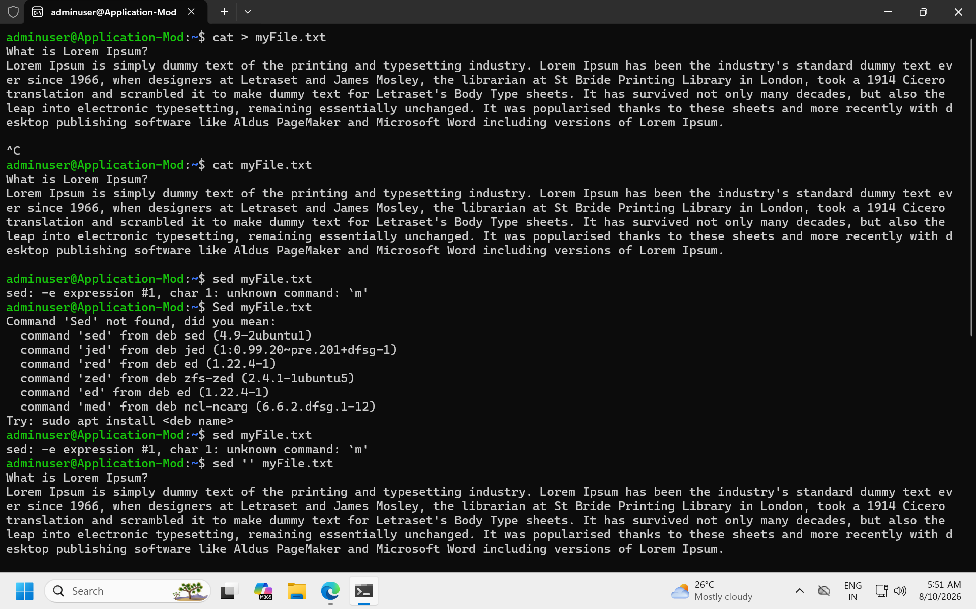
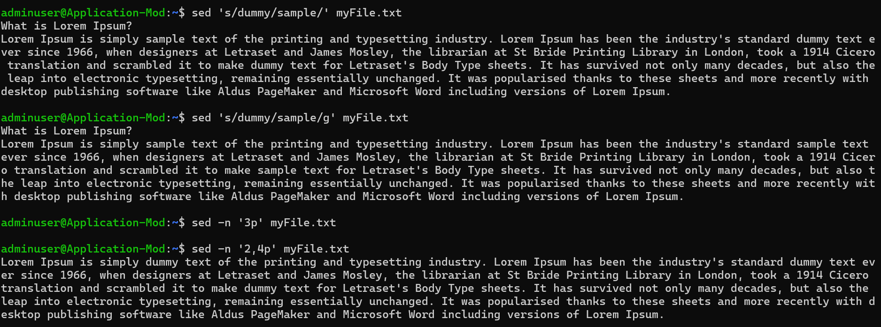
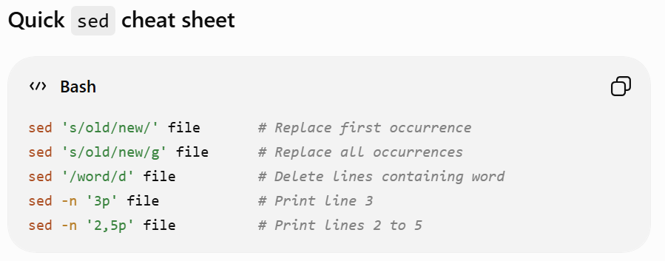

Task 2:
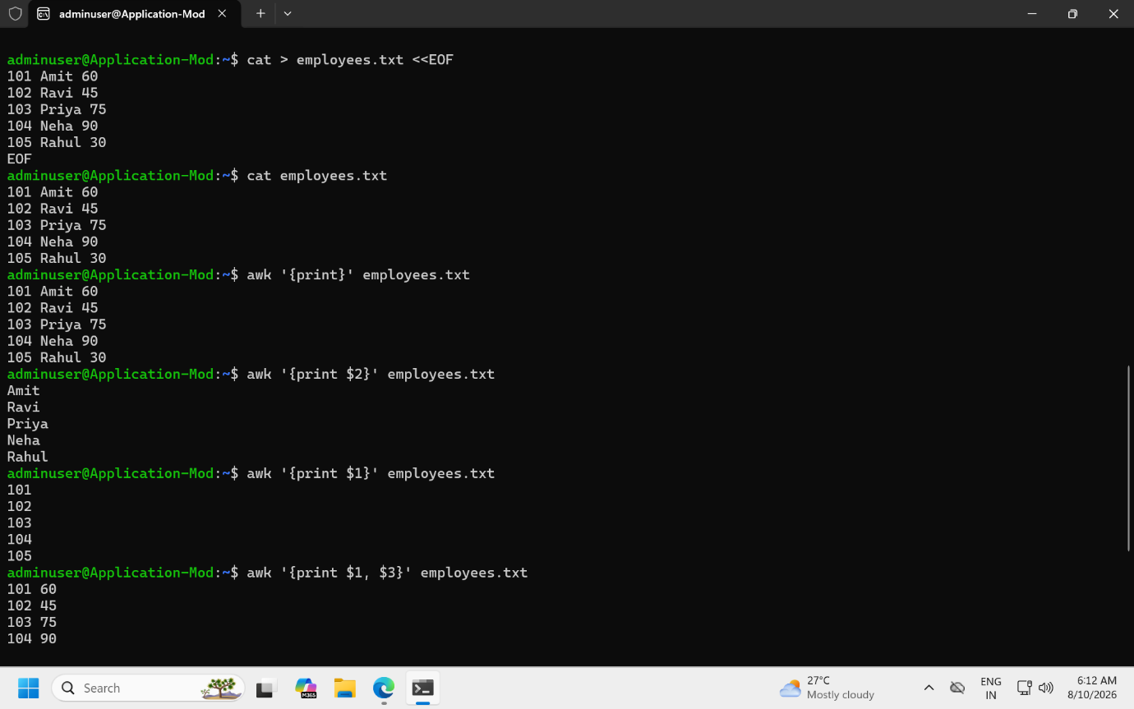
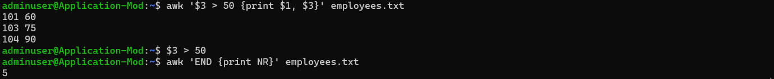
Task 5:
In Data Structures, a tree is a hierarchical, non-linear data structure consisting of nodes connected by edges.
Think of it like a family tree:
- The top node is called the root.
- Nodes connected below are called children.
- A node with no children is called a leaf node.
- Each node can have zero or more child nodes.
Task 6:
- Binary Tree
Example: Family hierarchy.
➜ Each node can have at most two children.
- Binary Search Tree (BST)
Example: Contact lookup system.
➜ Left node is smaller and right node is larger than the parent.
- AVL Tree
Example: Database searching.
➜ A self-balancing BST that maintains fast search operations.
- Red-Black Tree
Example: Java TreeMap, C++ map.
➜ A self-balancing BST that uses node colors to maintain balance.
- Heap (Min Heap / Max Heap)
Example: Priority Queue, CPU scheduling.
➜ Parent node is always smaller (Min Heap) or larger (Max Heap) than its children.
- Trie (Prefix Tree)
Example: Google autocomplete.
➜ Stores strings efficiently for fast prefix-based searching.
- B-Tree
Example: Database indexes.
➜ A multi-level balanced tree optimized for disk storage and retrieval.
Task 7:
A Binary Search Tree (BST) is a special type of Binary Tree where:
- All nodes in the left subtree are smaller than the parent node.
- All nodes in the right subtree are greater than the parent node.
Task 8:
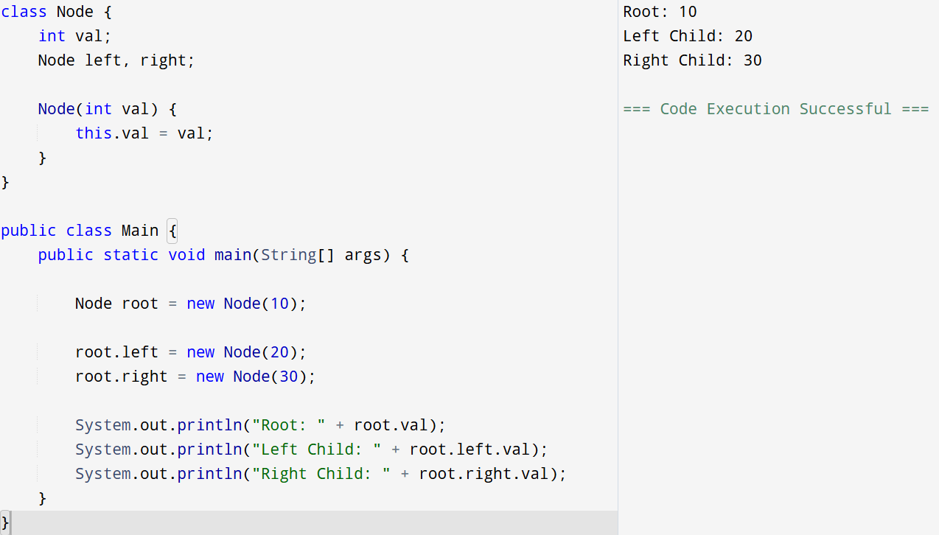
Task 9:
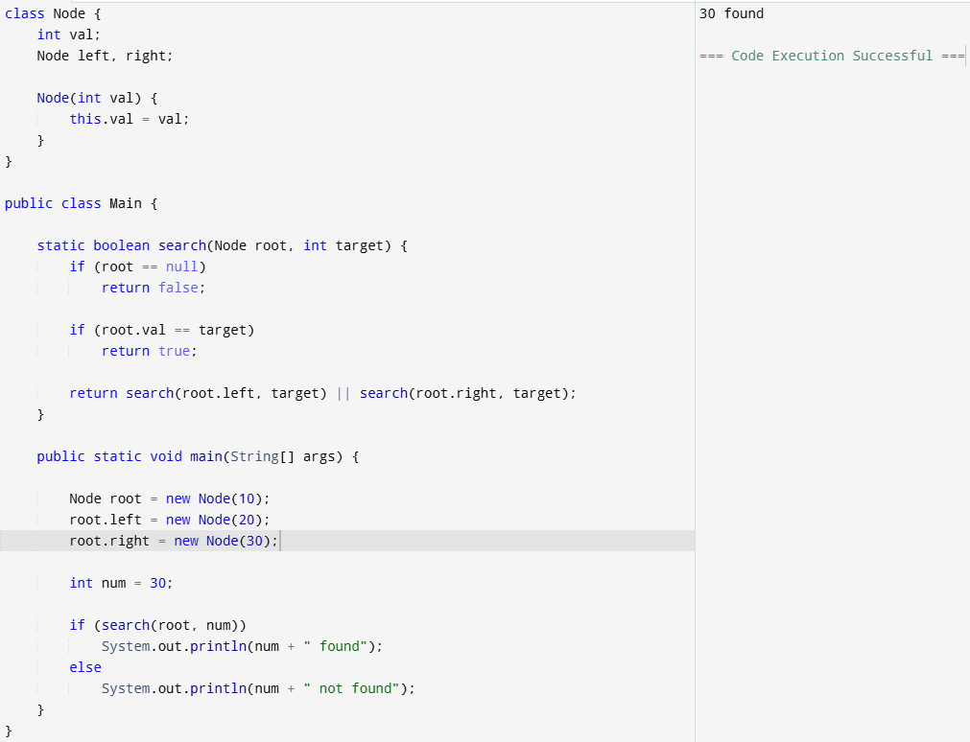
Task 10:
In a BST, in order traversal always prints the elements in sorted ascending order.
Left → Root → Right.
Task 11:
- BFS explores nodes level by level.
- DFS explores as deep as possible along one branch before backtracking.
BFS | DFS
Level-wise traversal | Depth-wise traversal
Uses Queue | Uses Stack/Recursion
Finds shortest path in unweighted graphs | Doesn't guarantee shortest path
Higher memory usage | Lower memory usage
Example: A B C D E F | Example: A B D E C F

Task 12:
BFS is implemented using a Queue because it processes nodes level by level (FIFO), whereas DFS is implemented using a Stack or Recursion because it explores one branch completely before backtracking (LIFO).
Task 13:
For an unweighted graph, the shortest path is found using BFS (Breadth-First Search).
Why BFS?
Because BFS visits nodes level by level. The first time you reach a node, you've reached it through the minimum number of edges.
Task 14:
Cycle detection means checking whether you can start from a node and come back to the same node by following the graph's edges.
Task 15:
HashMap stores key-value pairs in an array of buckets, uses hashCode() to locate the bucket, equals() to identify the key, handles collisions using a Linked List or Red-Black Tree, and performs rehashing when the load factor threshold is exceeded.
Task 16:
The key property of HashMap used to find the intersection of two arrays is its constant-time key lookup (containsKey()), which allows us to efficiently check whether an element from one array exists in the other, reducing the overall complexity from O(n²) to O(n).
Task 17:
A collision occurs when two different keys generate the same bucket index in a HashMap.
Task 18:
Size is the number of key-value pairs stored in the HashMap, whereas capacity is the number of buckets allocated internally for storing those entries.
Task 19:
HashMap allows:
- One null key
- Multiple null values
Eg – Predicted output
{null=InterviewBit, 1=Program to store null value}
- HashMap allows one null key, so null is stored successfully as a key.
- Since there are two entries (1 and null), both are printed when the map is displayed.
Task 20:
Yes, when we say "HashMap is not thread-safe", it means multiple threads can access and modify the same HashMap simultaneously, leading to inconsistent or corrupted data.
Task 21:
Yes, a HashMap can store multiple keys with the same value.
The restriction is on keys, not on values.
Task 22:
Feature | HashMap | Hash table
Thread Safety | ❌ Not synchronized (not thread-safe) | ✅ Synchronized (thread-safe)
Performance | Faster | Slower due to synchronization
Null Key | ✅ Allows one null key | ❌ Does not allow null keys
Null Values | ✅ Allows multiple null values | ❌ Does not allow null values
Introduced In | Java Collections Framework (Java 1.2) | Legacy class (Java 1.0)
Iterator | Uses Iterator | Uses Enumeration (legacy) and Iterator
Recommended Usage | Preferred in modern applications | Rarely used today

Task 23:
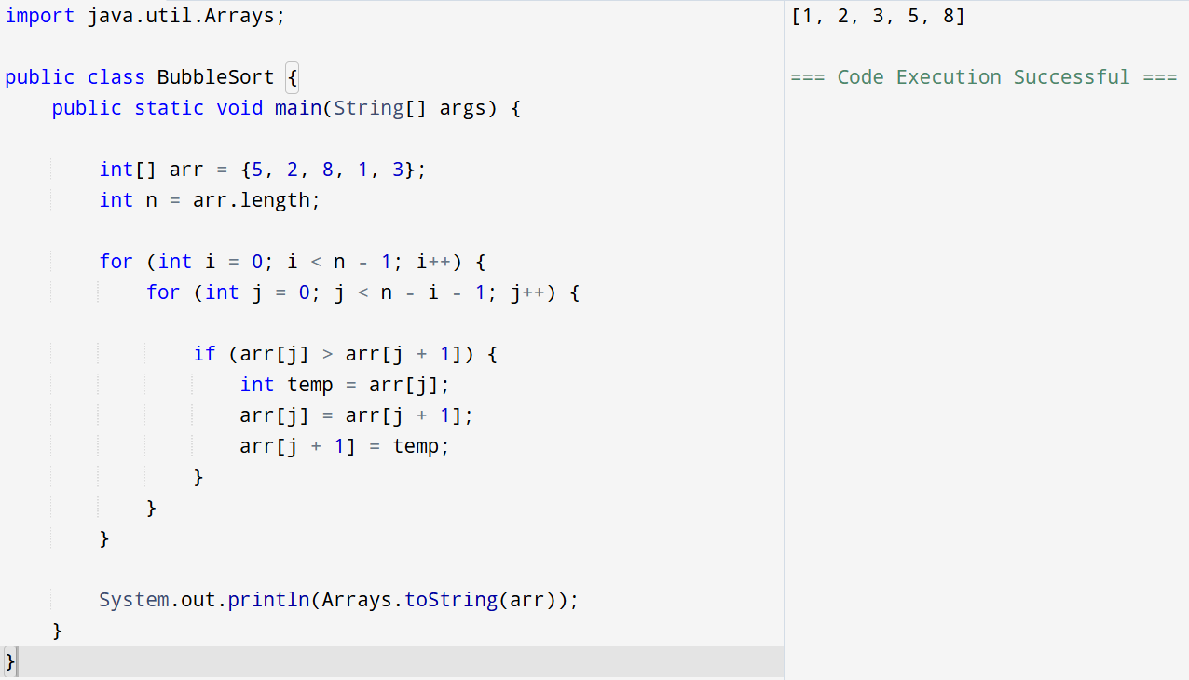
Task 24:
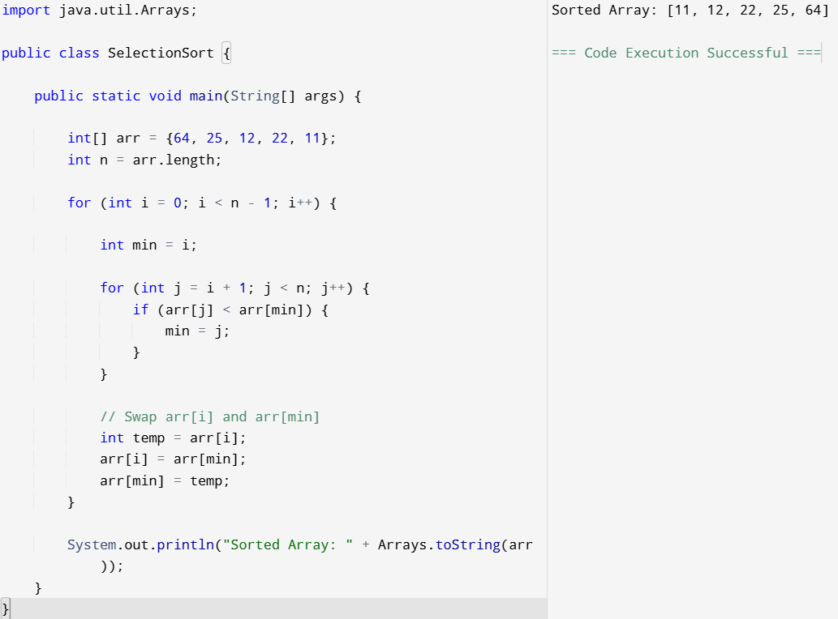

Task 25:
